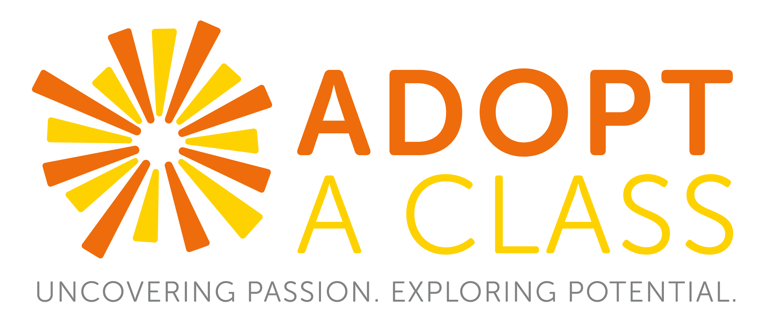
Beginning of Year Checklist
School is back in session and we can’t wait to get back in the classroom. Below are key actions to help you and your team prepare for this year’s program:

- Sign AAC’s Adopter Handbook. We care about ensuring a safe and quality program for everyone. We know this is something you care about too. Each year, every Team Lead must sign our Adopter Handbook to make sure every volunteer understands our program and safety guidelines. Before signing, please read through this handbook in its entirety and share with your team. As indicated in the Handbook, only Team Leads should sign this document as their signature attests that all team members agree to the policies and procedures outlined. The signature page is at the end of the document. Review and sign here.

- [New Teams} Sign Up for New Adopter Orientation: In preparation for your first classroom visit, we highly recommend all new adopters take part in our New Adopter Orientation. It focuses on classroom management, age appropriate communication and setting expectations. The training is one hour-long and we will facilitate the training at your office. To schedule an orientation session contact Marie Rusincovitch, Director of Programming, at marie@aacmentors.org.

- Schedule a Planning Meeting with Your Teacher. The AAC model is that your team stays with the same teacher year to year. Assuming nothing has changed, please reach out to your teacher to start planning your calendar of visits. As a reminder, when scheduling out your calendar, it is best to pick a cadence that works well for the team and your teacher (e.g. first Tuesday of the month at 8am).

Your teacher is also a great resource in determining what kinds of activities and topics will resonate with the students. Here are a few curriculum questions for your teacher – what information do you need to know about the school and your class to help your team better prepare? (e.g. what are the dynamics in the class? What are some challenges his/her students face? [bullying, homelessness, etc.])? Are there opportunities to align your activities to your teacher’s curriculum?

- Start Planning with Your Team. After reconnecting with your teacher, we highly encourage you meet with your team(s) to discuss curriculum and start preparing for your first visits. Your team discussions should include:
- Calendaring – When are you going into the classroom?
- Curriculum – What topics do we want to cover each month? How can your team bring your organization’s mission and values into the classroom? Remember most of your activities should incorporate STEM, Life Skills and/or College & Career.
- Team Roles – Each team is structured differently. How will you structure yours? Who will manage monthly activities? AAC App? Pen Pal Letters?
- Pen Palling – How will you facilitate your pen pal program this year?
- Budget – How much money will our team have available for this year’s program? Will we need to fundraise?
- Communication – How will we keep each other informed as well as your organization throughout the year?

- Log Your Classroom Visits! Tracking your visits is critical to the success of our program for it allows us to quantify the impact you are making in the classroom. Additionally, your logs matter because the information from in this report helps 1) your school meet its requirements of bringing college and career activities to the classroom 2) us GET GRANTS. Yes, funders like to see what the <insert company names> teams are doing, and 3) your organization keep a reported log of all the contributions made throughout the year! To log a visit, sign on at https://aacmentors.org/log-in/ and enter your team lead’s email address.

- Keep AAC in the Loop! Every team is granted an AAC team member point of contact as on-going support to YOU. We want to stay connected throughout the year as well keep you informed of key happenings as they come up. Please share your calendar of visits (once ready) so we can come visit your team sometime this year.

